Checking the database changes via SQL Server Database project

SQL Server Database project allows develop, manage, compare and deploy the database changes using **Visual Studio**.

In order to open and check the database follow these steps:

1. Open solution using MS Visual Studio:

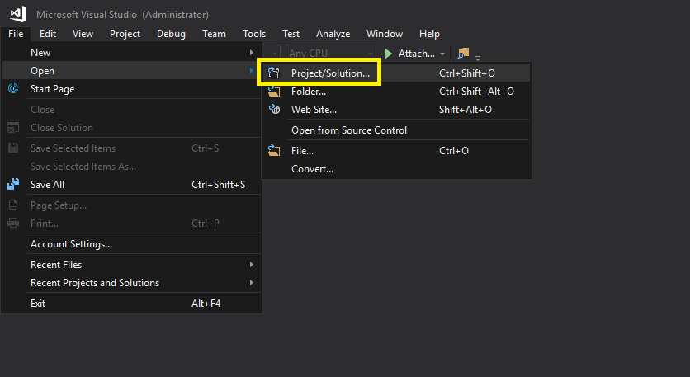

Navigate to your local repository copy:

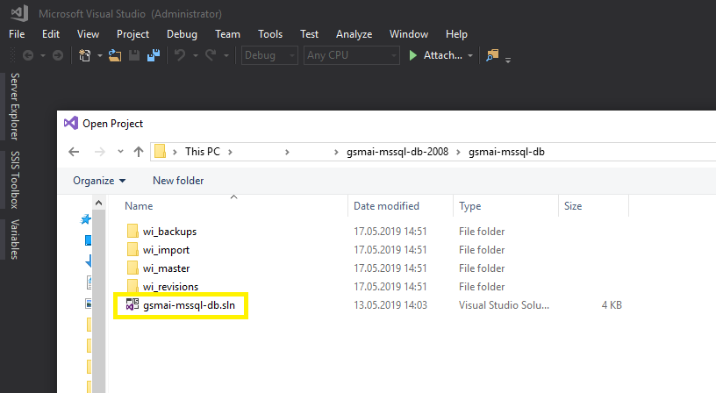

1. **Build** **Solution** (right-click at solution ‘gsmai-mssql-db’)

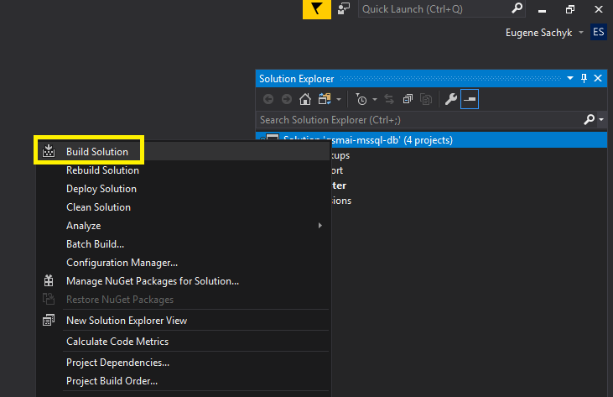

Check that it succeeded:

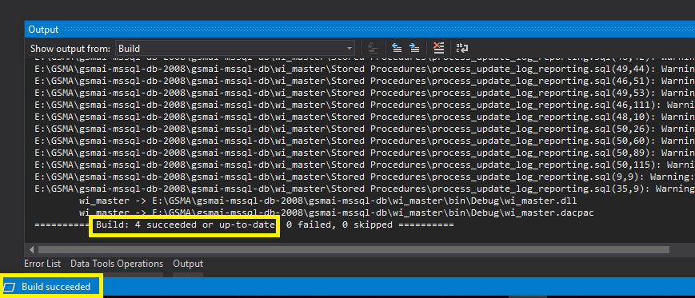

1. Open **Schema Compare** for the required database:

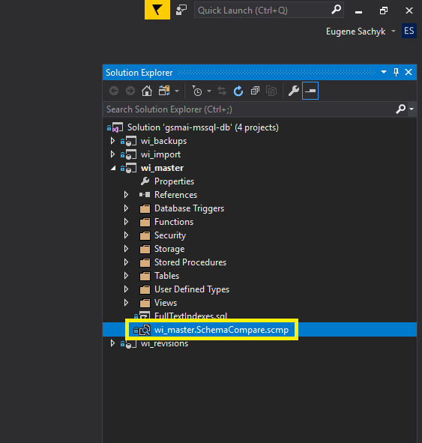

Check the connection settings (right side of the screen) and click **Compare**:

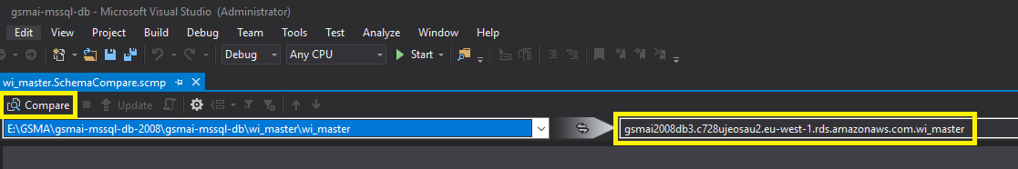

1. Once the comparison completed, check the type of the discrepancy, object type and name and the actual difference in the code:

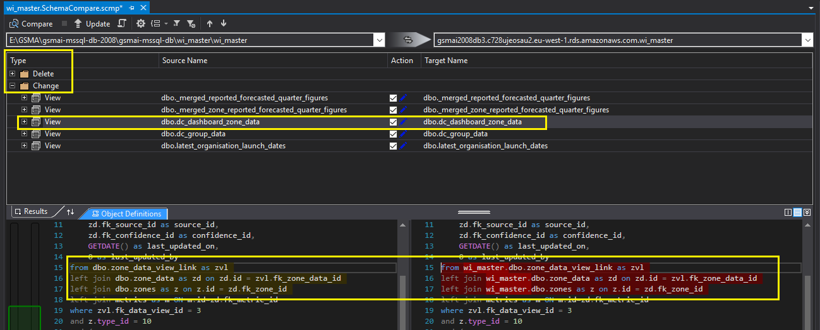

1. Use the **Action** section to include/exclude objects to be updated and click **Generate Script**:

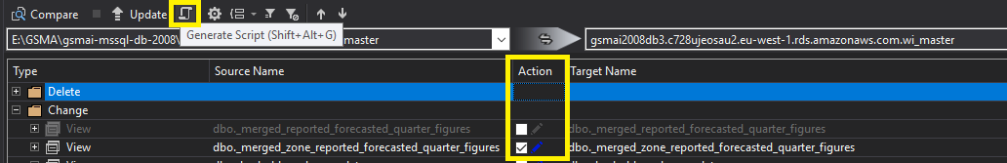

The update script will appear on the adjacent tab:

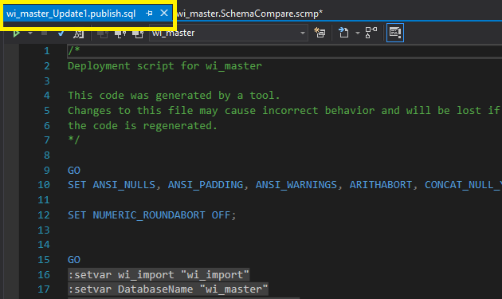

Please keep in mind that you should use **SQLCMD mode** to run it either via Visual Studio or MS SQL Server Management Studio.

You can also update the code in the repository – just find the object and make the required changes:

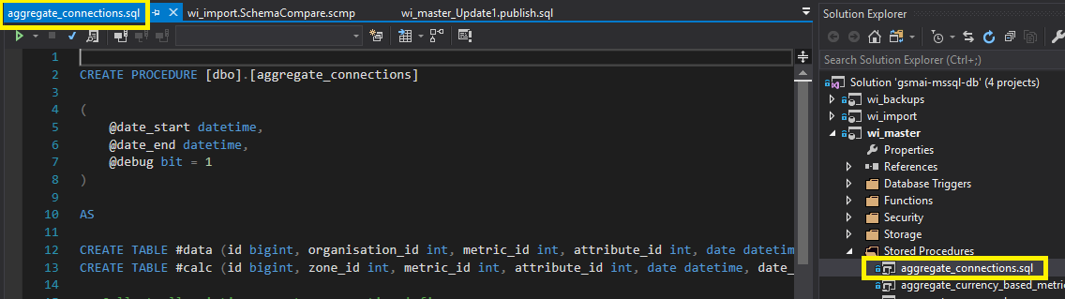

If there is no difference between the database and the repository you will see this:

